NFL Game Reservation

Developed By: Ayush Patel

Created on: April 28, 2017

Table of Contents

Introduction……………………………………………………………………………………………………….3

Homepage………………………………………………………………………………………………………….3

Sign Up……………………………………………………………………………………………………………….4

Login………………………………………………………………………………………………………………….5

Reservation Room…………………….………………………………………………………………………..8

Game Schedule……………………………….………………………………………………………………….9

Your Reservations…………………………………………………………………………………………….10



NFL Game Reservation provides a suitable platform for the customers to buy the game tickets for National Football League. The system provides an easy and efficient way to book the tickets.

The user needs to sign up for the website and then he/she can login into the account using credentials. The customers can buy tickets for their desired games at affordable prices.

Homepage

The Homepage of the application makes a user sentient of the different types of sports available for buying through interactive images. It provides a link for the Customer to Login and Sign Up using which he/she can buy the tickets for the game events.

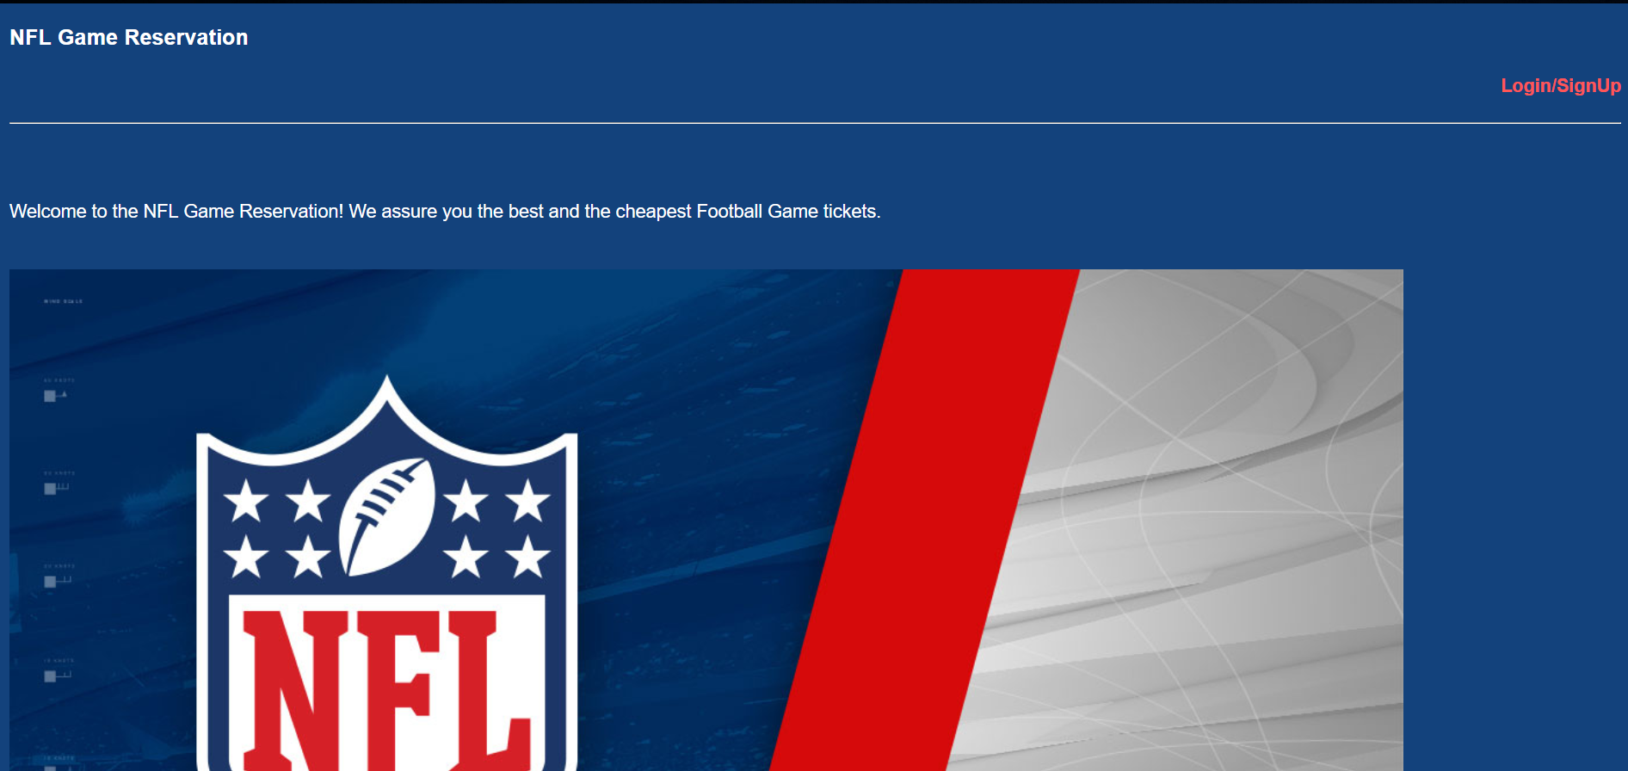

Sign Up

Customers who are not previously registered on the website are expected to create an account by entering the required information at the designated place. After entering the correct essentials, user can create an account by clicking on the **‘Create Account’** button.

The following image displays the needed fields to be entered by the user. Once the user clicks on the Create Account button, he/she will be redirected to thanks.jsp webpage as follows which provides the information entered by the user and giving the confirmation.



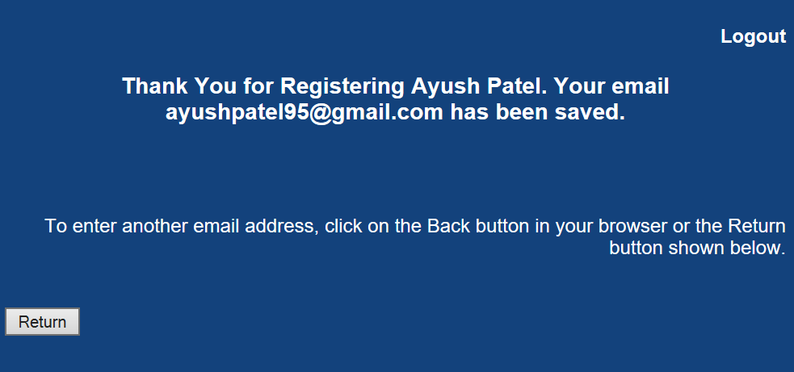

Login

1. **Customer:**

The customers who are previously registered on the website can comfortably login into the application using the credentials **‘Username’** and **‘Password’**. By clicking on the **‘Log In’** button, the user will be redirected to the index page of the website. The webpage will contain several options for the user which are as follows:

* Events – Contains information regarding various events.
* About Us – A brief description about the Website.
* Contact Us – For any assistance or support.

The incorrect credentials will not allow a user to login into the account and thus displaying the same page for the user in order to re-enter the credentials after clicking on the Log In button.

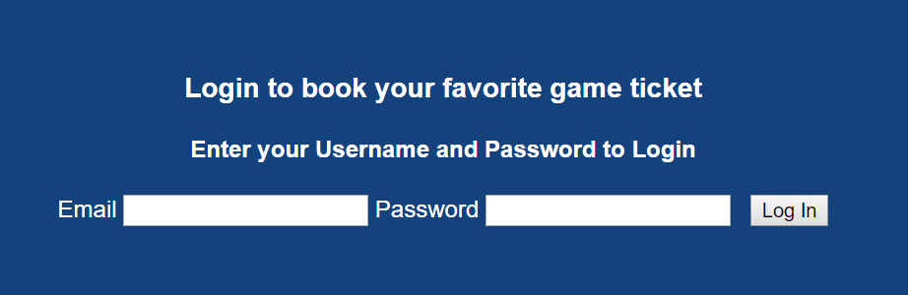

A Successful Login will redirect to the following page:

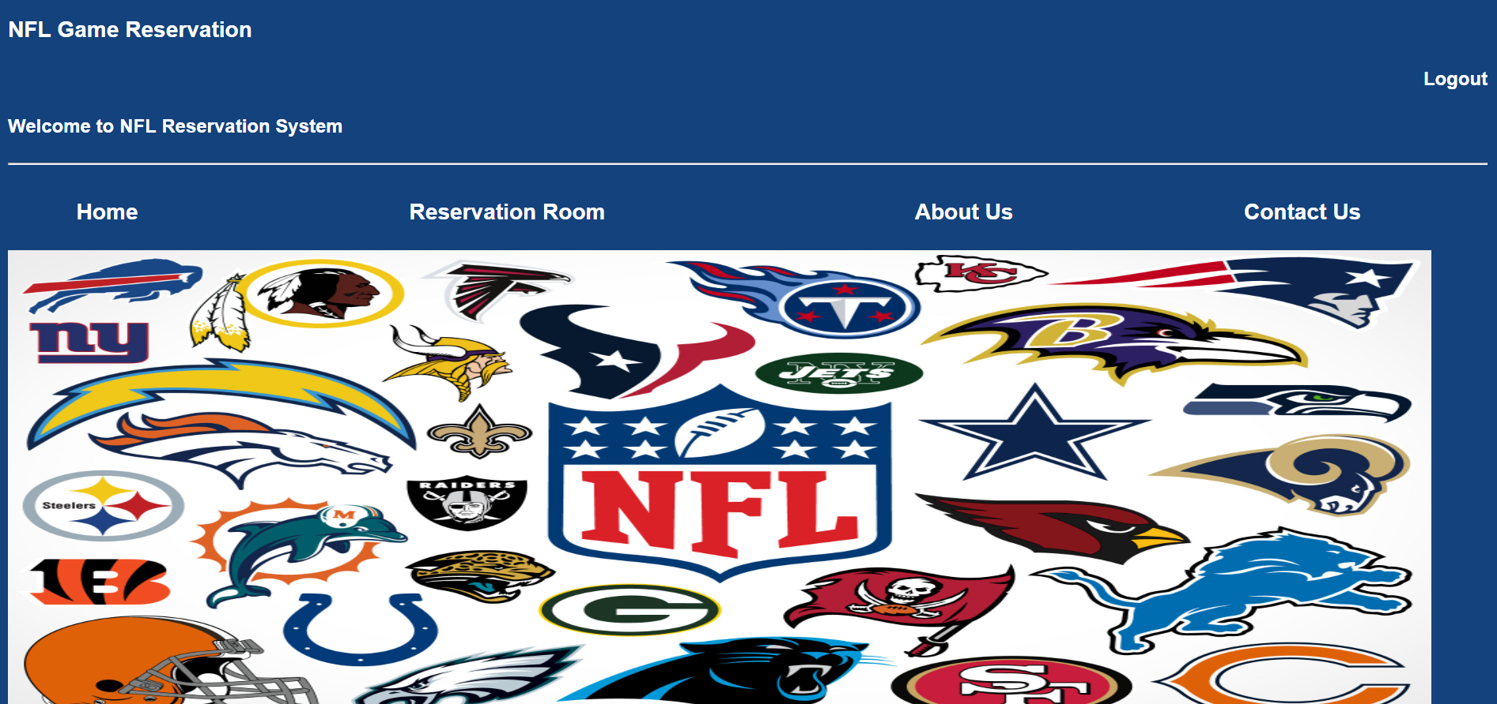

1. **Administrator:**

The authorized Administrators are provided with the personal credentials which can be used for the login. Using the account, the administrator will be able to add an event and make it available for the customers. He/she will also be able to view all the events.

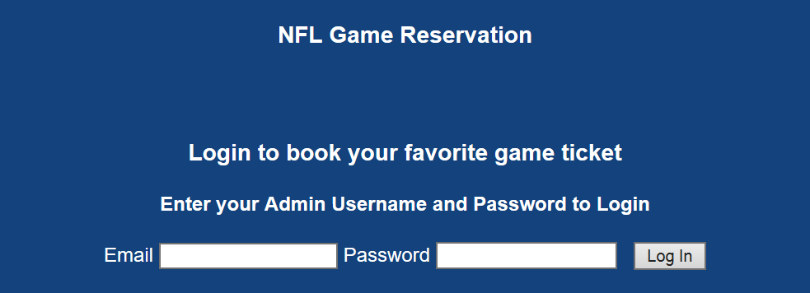

Adding an Event:

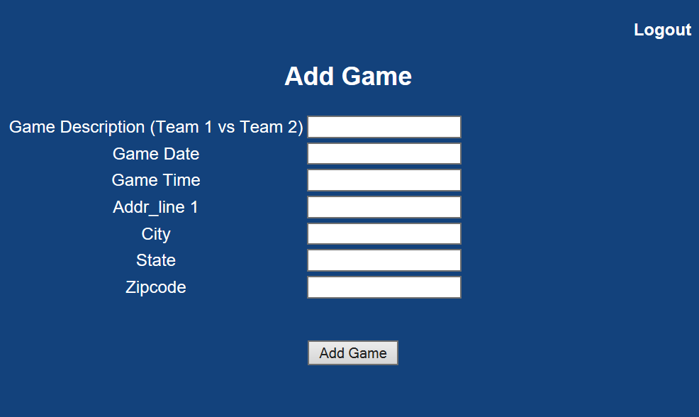

Admin View of Events:

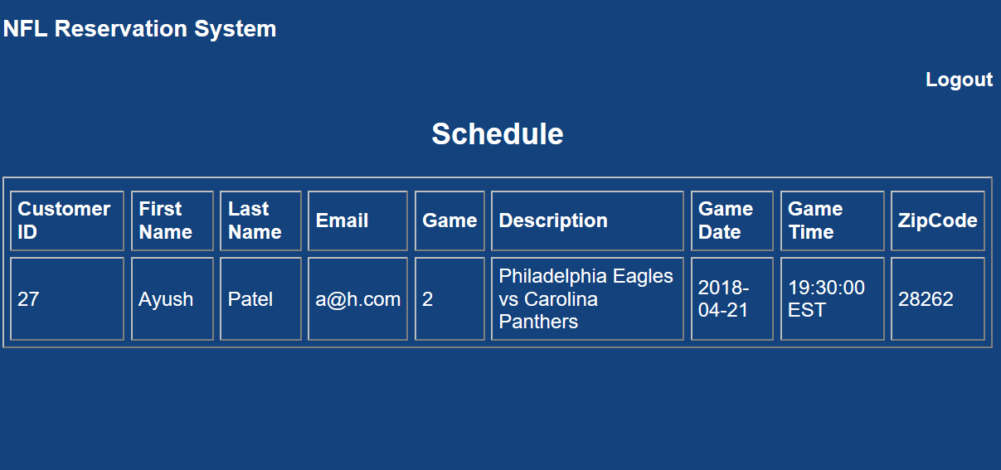

Add Another Admin :



Reservation Room

The reservation room webpage provides the user with two options, Game Schedule and Your Reservations. The user by clicking on this links can redirect to the respective webpage.

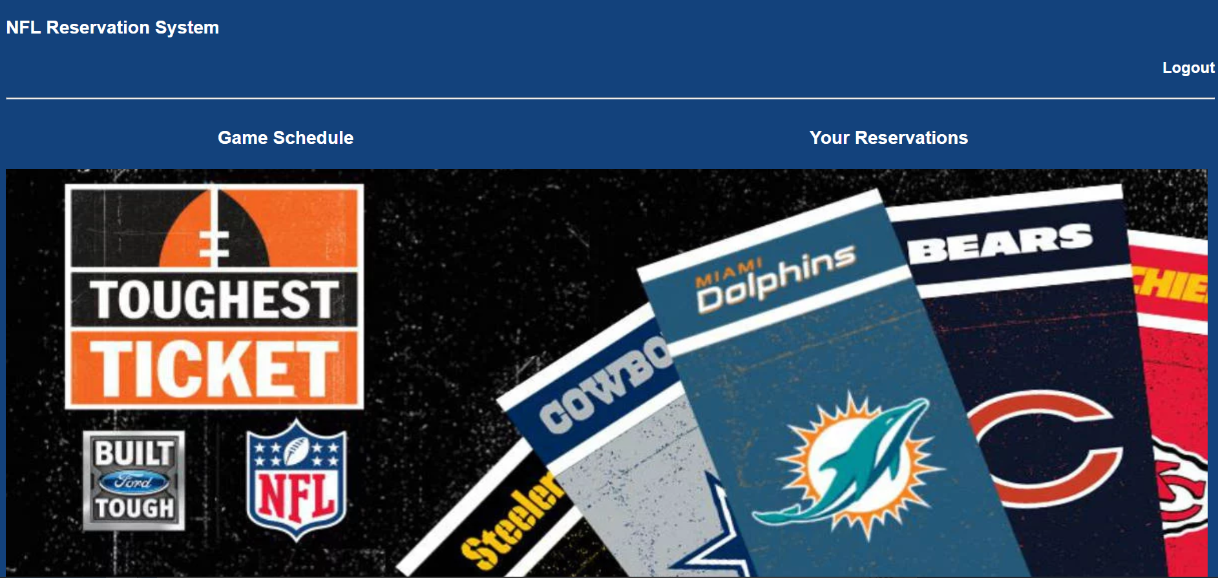

Game Schedule

The user can see the schedule of the NFL games and can also book ticket for the particular game. Clicking on the book button will redirect them to another webpage for confirmation.

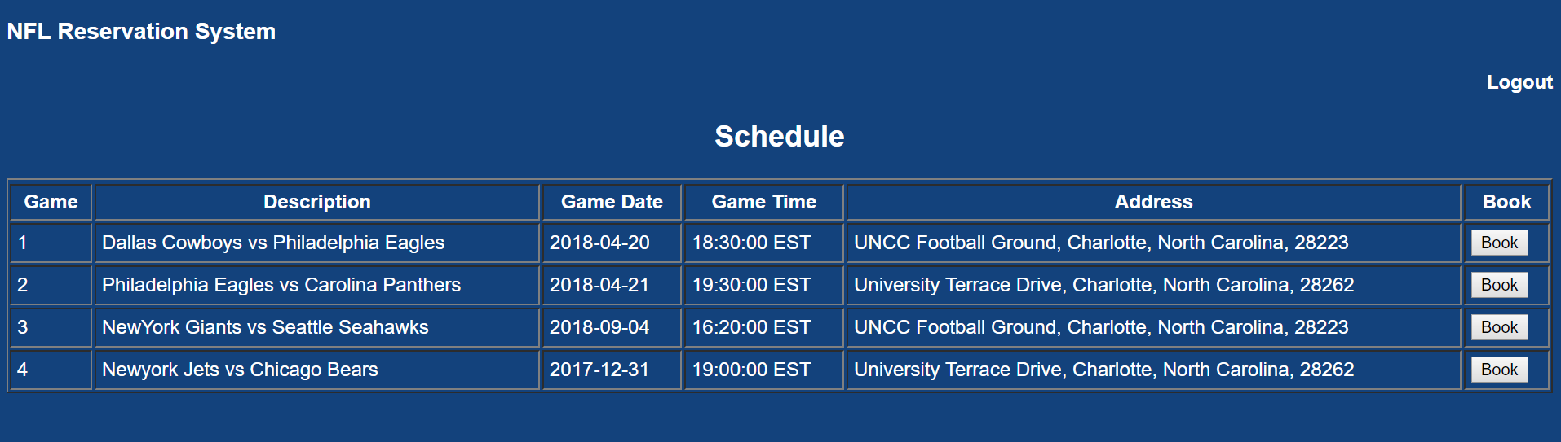

Booking Confirmation Webpage

The web page will asks the user for their confirmation for booking of the ticket. When the user clicks the confirm button, an email is sent to the user containing the ticket details.

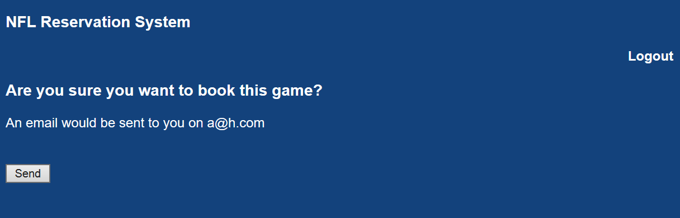

Your Reservations Webpage

The user can see the list of their reservations. The user can get a copy of their ticket sent via email when they choose Resend. The user can also cancel his ticket by pressing the cancel button which will redirect him to the cancel confirmation webpage.

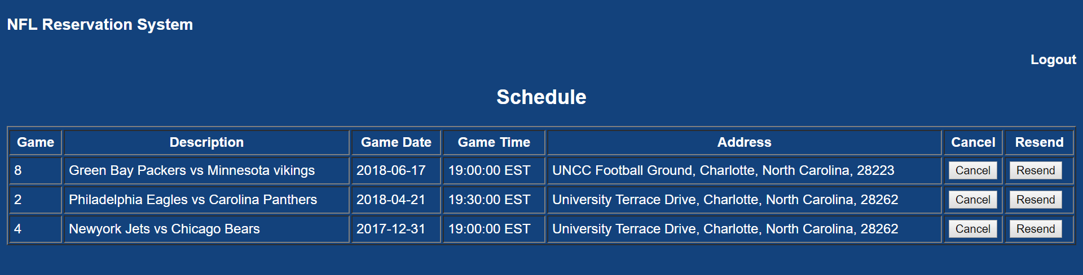

Cancel Confirmation Webpage

The web page will asks the user for their confirmation for cancellation of the ticket. When the user clicks the confirm button, an email is sent to the user containing the confirmation of ticket cancellation.

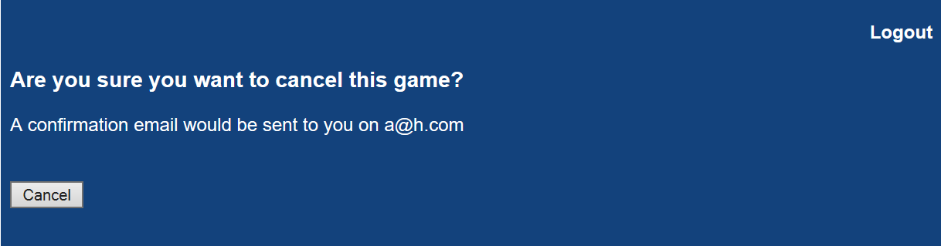

Email sent to the user

